1. A waveform is a essentially a function with respect to the output and whether its active or not, at least in this case
2. The testbench is where we declare all of the values for the inputs and outputs and checks to see whether if the outputs match the function’s specifications
3. We actually can change the 4 input and gates to 2 input and gates, we’d just need to place them in this formation

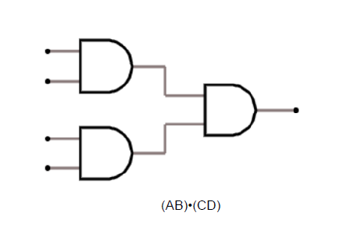

Sprinkler

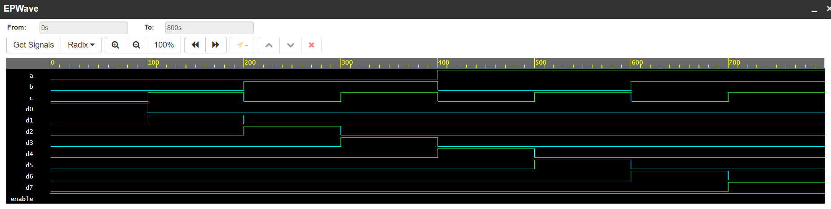

MUX

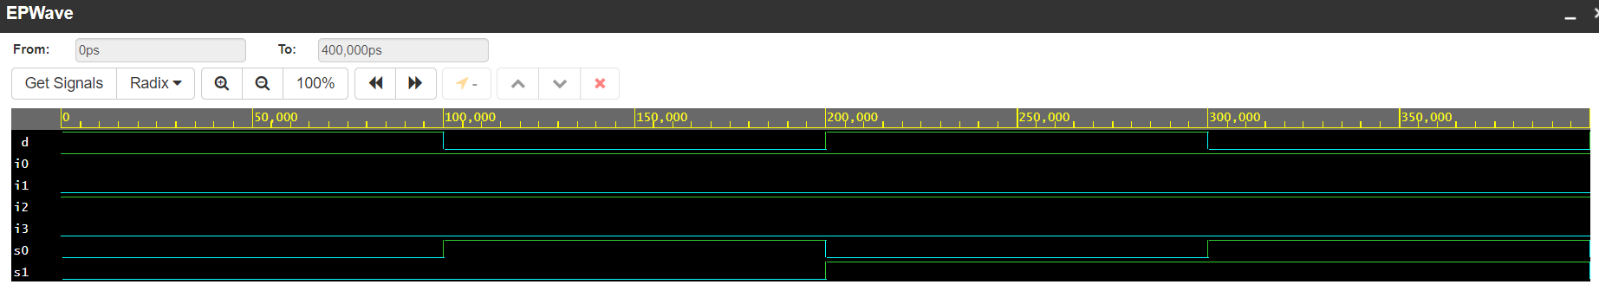

We can make sure we implemented our code correctly by checking the waveform output of the program. If we also compare the waveform to our algebraic expression and our truth table, we are able to see that the values of the inputs do correspond with the outputs.

Demonstration: Demo the waveform obtained during the behavioral simulation and explain why it is correct. Provide the truth table, algebraic expression of the logic function, and logic circuit schematic.

Algebraic expression

I0s1’s0’ +I1s1s0’ +I2s1’s0 + I3s1s0 = F

Truth Table

| s1 | s0 | i0 | i1 | i2 | i3 | d |
| --- | --- | --- | --- | --- | --- | --- |
| 0 | 0 | 0 | 1 | 0 | 1 | 0 |
| 0 | 1 | 0 | 1 | 0 | 1 | 1 |
| 1 | 0 | 0 | 1 | 0 | 1 | 0 |
| 1 | 1 | 0 | 1 | 0 | 1 | 1 |

Logic Circuit

